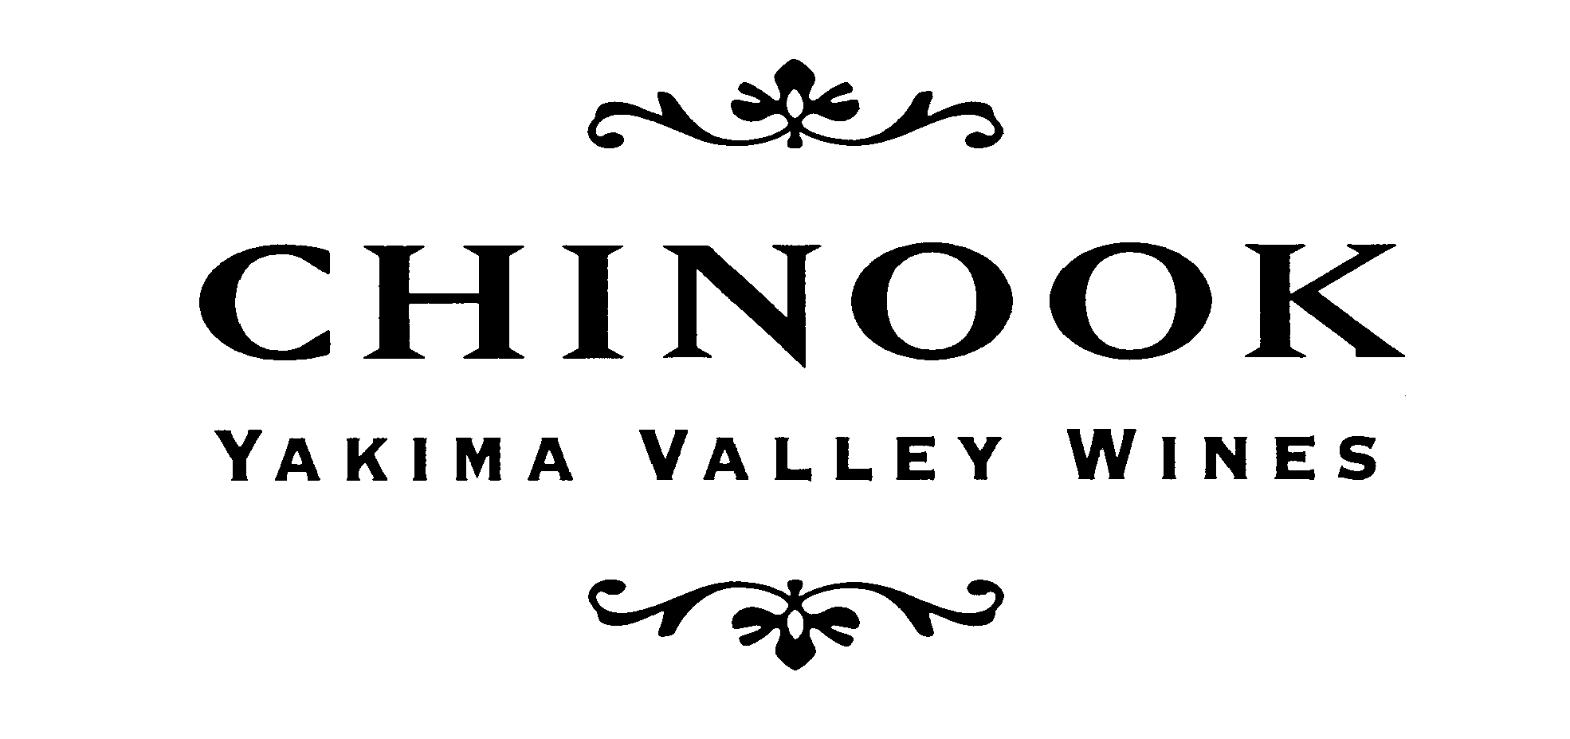

A Tasting of Chinook Wines
JULY, 2013
We’re enjoying our 30th anniversary year!

-WHITES-

2011 Yakima Valley Semillon: SOLD OUT – NEW VINTAGE COMING SOON!
Price is: $13.99 per 750ml bottle

2012 Yakima Valley Sauvignon blanc: Our Sauvignon blanc includes fruit from the third vintage of a clonal trial at the denHoed’s vineyard North of Prosser. The range of aroma & flavor components are complex. The 2012 Sauvignon blanc has a crisp balance of body & acidity. We fermented the juice at a cool temperature to retain floral & fruity aromas such as pear and citrus fruits. We find this wine perfectly matched with herbed chevre from Rollingstone Chevre (Treasure Valley, ID).
Price is: $17.99 per 750ml bottle

2011 Yakima Valley Chardonnay: Chinook's Chardonnay grapes are grown by multi-generational Yakima Valley vineyard families who sell us their 'old vine' Chardonnay - truly OLD vines. The winegrape pioneering families Carter, denHoed & Roy planted these vines to provide for the emerging wineries in the Yakima Valley. Fruit from these vineyards results in flavors in the wine reminiscent of tropical fruits (pineapple) & Granny Smith apples. These flavors were amplified by aging in lightly toasted oak barrels, which added a subtle vanilla aroma.
Price is $18.99 per 750ml bottle.

Non-vintage Yakima Valley White Wine VII: We know that Chinook is known for its white wines, as well as the drinkable reds. We have blended another simple white blend for your every day enjoyment: it’s a blend of Semillon, Sauvignon blanc and a bit of Chardonnay. We recommend it for an aperitif or with meatless entrees such as vegetable lasagna.
Price is a reasonable $.12 99 per 750ml bottle.
sales@chinookwines.com

A tasting of CHINOOK Winery’s wines cont. – JULY, 2013

-REDS & ROSÉ-

2012 Yakima Valley Cabernet Franc Rose: : JUST RELEASED! We are excited about this, our fifteenth vintage of Cab Franc Rose. A careful blend of fruit from Dutchman and Lonesome Spring vineyards, it smells reminiscent of strawberry freezer jam. Long a favorite with salty snacks or fresh summer salads.
Price is $15.99 per 750ml bottle

2010 Chinook Yakima Valley CABERNET FRANC: For over 15 years, Chinook has produced a Cabernet Franc from our estate vineyard and selected growers' fruit in the Yakima Valley. The 2010 Cabernet Franc is 100% varietal and from 100% Yakima Valley AVA fruit. Our hands-on, minimal processing produces a Franc that is soft, drinkable and low in tannins. This remains the most rustic-styled of our wines. To emphasize the recognizable Cabernet Franc characteristics (cherries, raspberries, licorice, violets) we choose to age this wine in neutral oak. In the 2010 season, grapes were grown at Chinook’s Estate Vineyard, Boushey Vineyards, Carter Farm and Desert Hills Vineyards.
Price is $22.99 per 750ml bottle

2009 CHINOOK Yakima Valley Merlot: CHINOOK WINES has been producing Merlot since 1984, and the vintages just get better with age. Vanilla, plum or cherry are some of the interesting mix of aromas and flavors you might find in this wine. Natural food affinities are lamb or herb-crusted salmon on the grill.
Price is $23.99 per 750ml bottle.

Yakima Valley Red Wine BLEND XVII: This easy-sipping wine is a blend of select vintages of Merlot, Cabernet Franc AND Cabernet Sauvignon. The latest Yakima Red has a rich garnet color with ripe purple-fruit aromas (plum & red cherry). These aromas are reflected in similar ripe flavors in the mouth. We suggest you open a bottle & enjoy it with an artisan pizza.
Price is $15.99 per 750ml bottle.

2008 CHINOOK Yakima Valley Cabernet Sauvignon: SOLD OUT! This very limited production of Cabernet Sauvignon from the historic Yakima Valley . . . Enjoy it right away or years in the future.

For more information or to order, contact Kay Simon & Clay Mackey of Chinook Wines
Tel. 509-786-2725; sales@chinookwines.com

